Telanagana State Industrial Project Approval & Self Certification System (TS-iPASS)

Collector / Commissioner Login Incentive Module
USER MANUAL
Prepared by



FRUX Software Solutions Pvt. Ltd.,
Flat 401, SVP Residency, Lane: 5,
Balaji Nagar, Nizampet, Hyderabad,
Telangana-500090.

Login Screen:

Login Screen
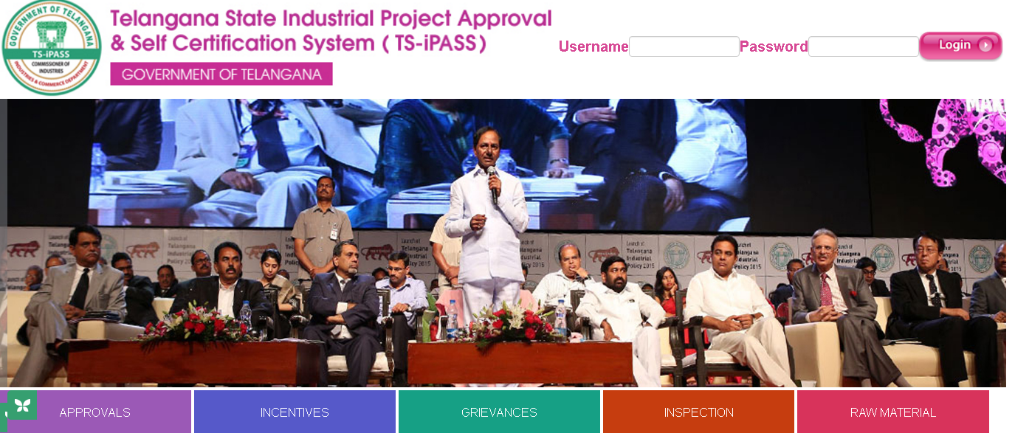
Screen Description:

This screen is used to Authenticate and Authorize for accessing and using different features and functionalities in Telanagana State Industrial Project Approval & Self Certification System (TS-iPASS). You can Login to the application by providing your User Credentials like User Name and Password.
Sl. No | Input Type | Description | Mandatory (Yes/No/NA)
1 | User Name | Enter the User name | Yes
2 | Password | Enter the Password | Yes
3 | Login | Click on Login button to log into the MIS | Yes
4 | Cancel | Click on Cancel to clear the columns in the Login Page | NA

Work flow of Commissioner / Collector in Incentive Module:

Receiving of approved applications by DIC with GM certificate

Approving / Rejecting the Incentive applications

Updating SLC Number, SLC Date & SLC amount issuing to that entrepreneur and submitting the data.

Generation of Sanction Order

Incentives Menu
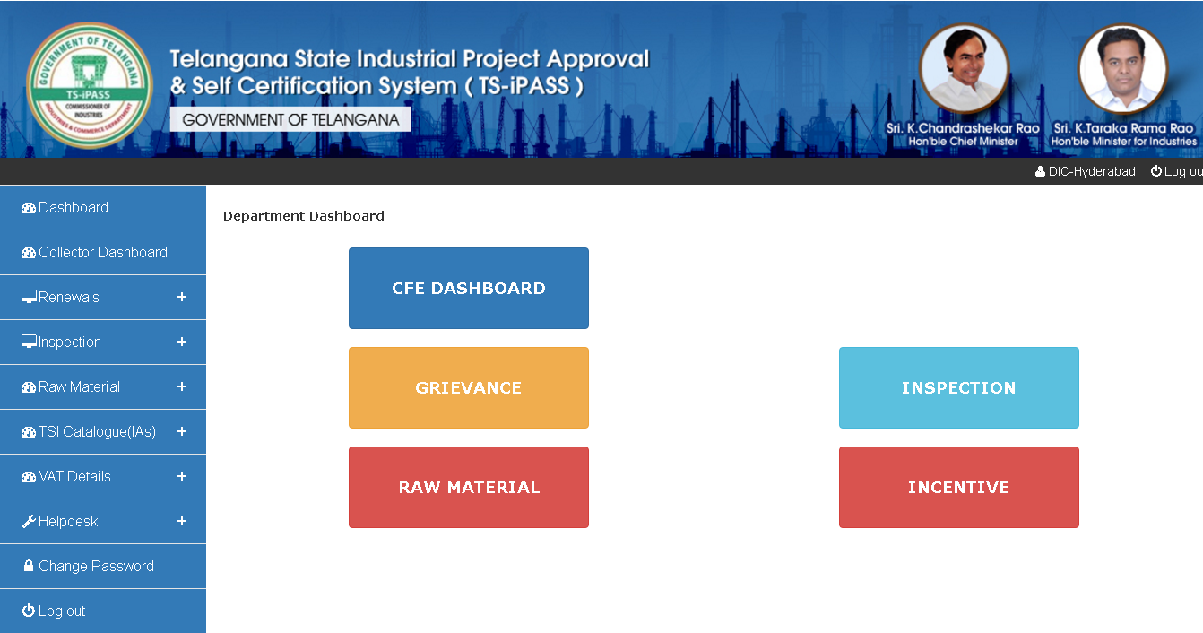
Screen Description: When you click on Incentives under Dashboard below screen will be displayed.

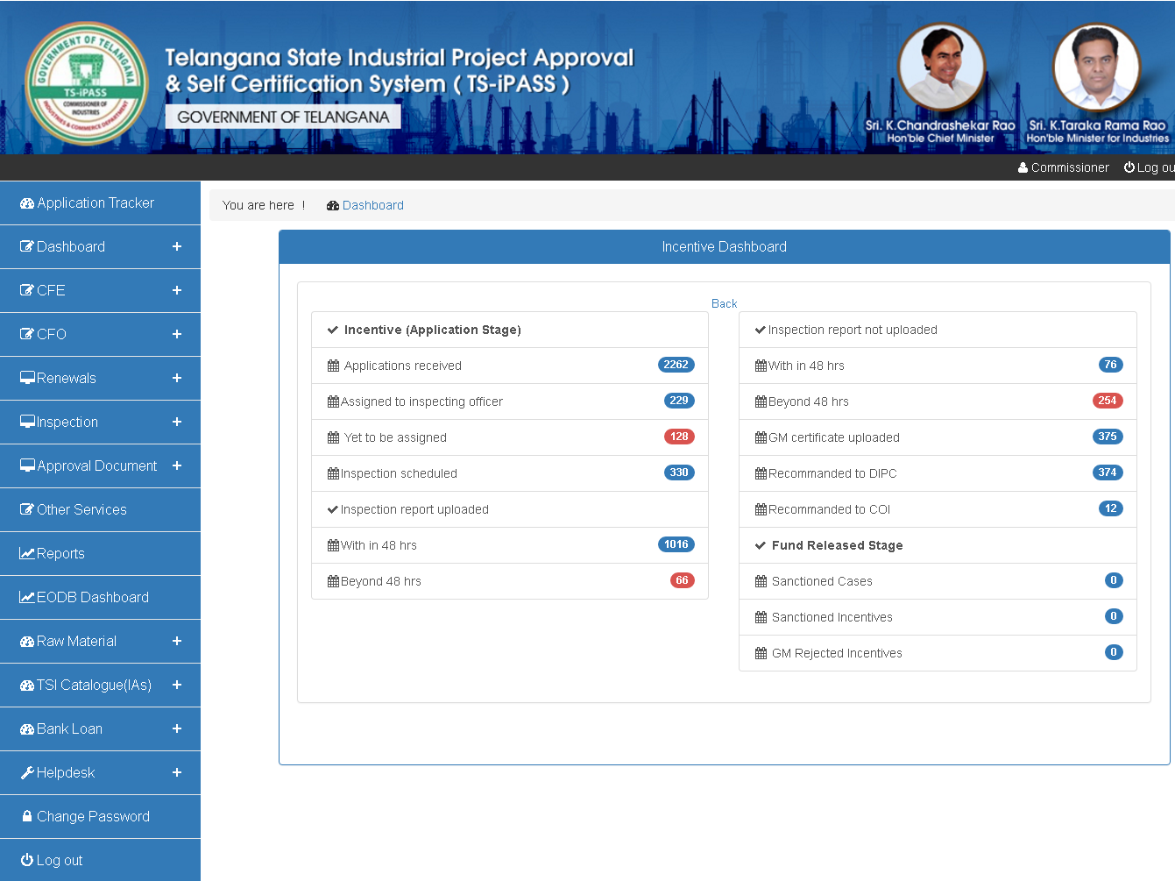
When you click on Recommended to COI option in the above login, below screen will be displayed:

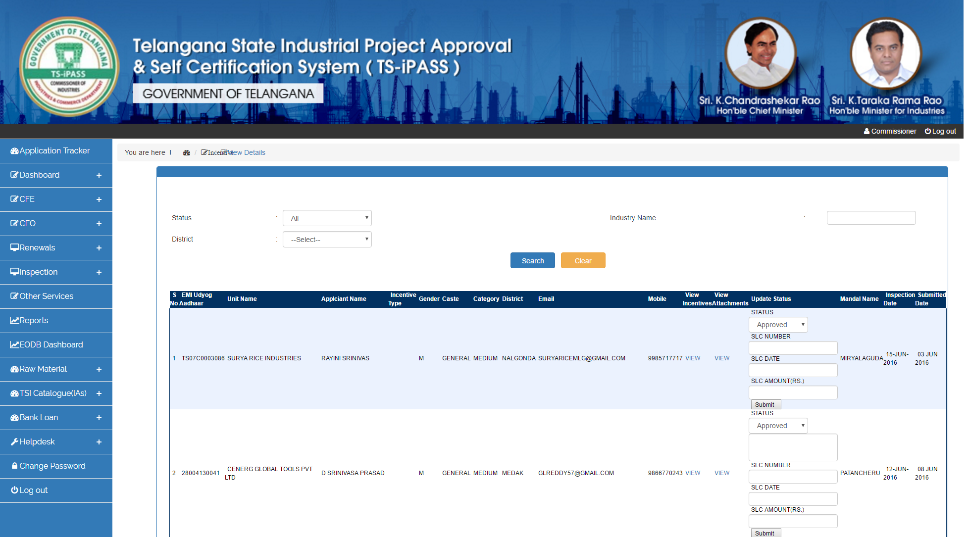
Screen Description: This screen is used to Approve / Reject the Incentive application forwarded by DIC and for updating SLC Number, SLC Date and SLC amount to the approved applications for generation of Sanction order.

****** Thank You ******

